Dacathlon Data Engineer Case Study

Task 1: Data extraction – Python

Example: store1 request output of sport places

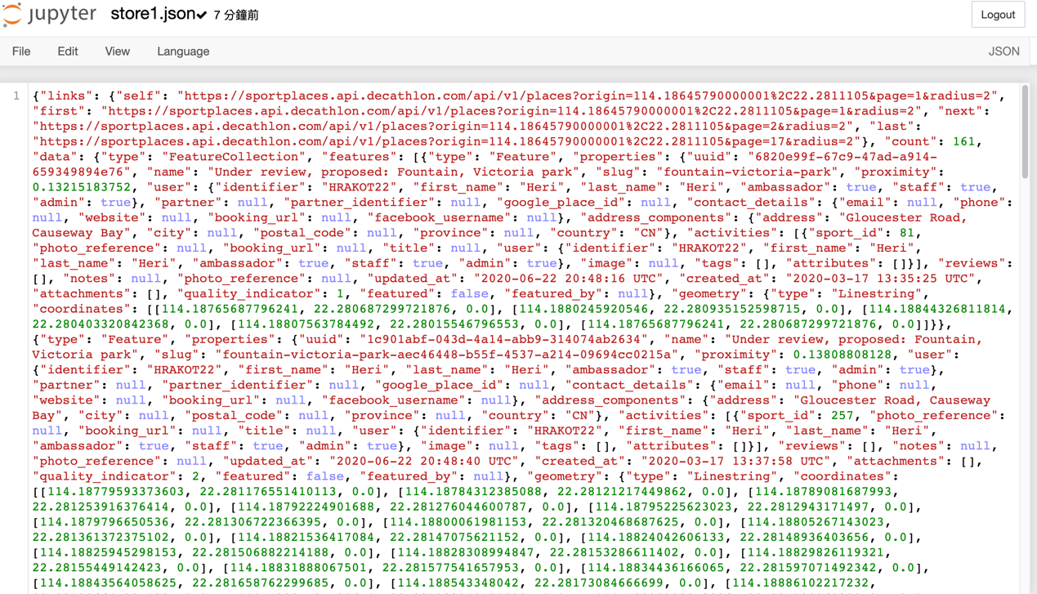

Task 2: Data processing: A) Pyspark pipeline – PySpark

The final result output of Pyspark DataFrame

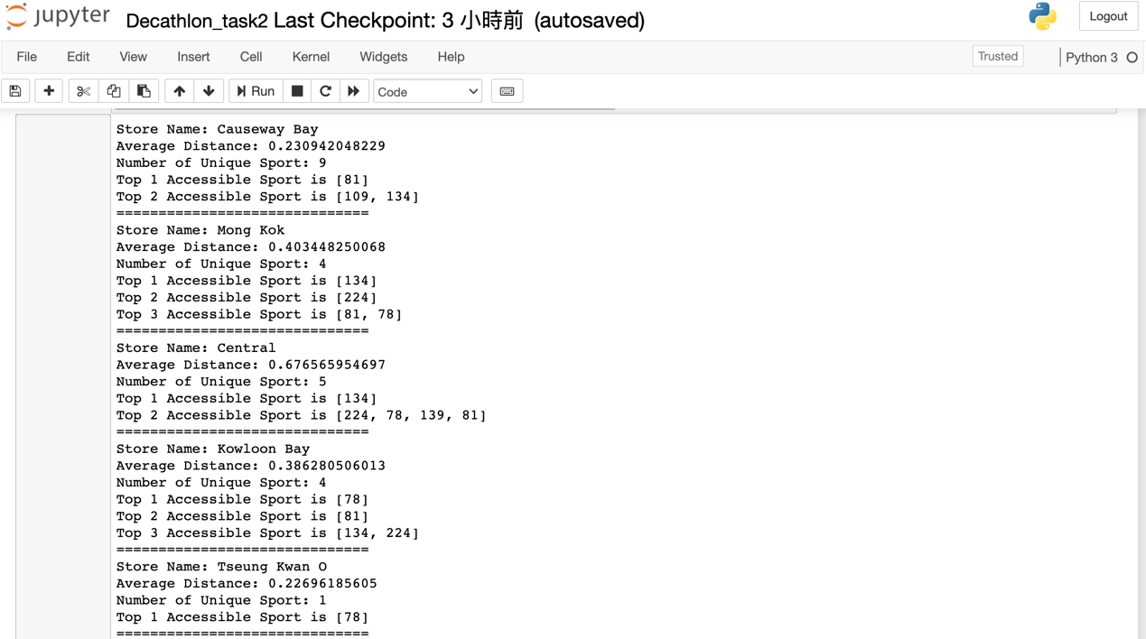

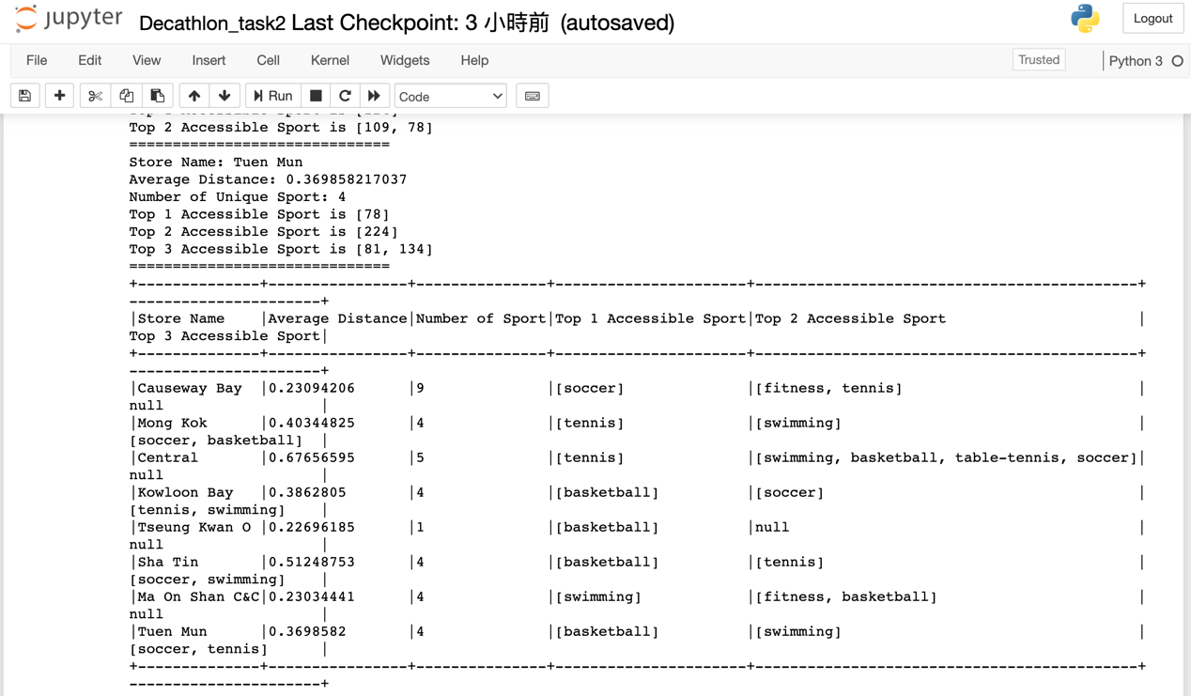

Task 2: Data processing: B) Redshift pipeline – SQL

The result of calculate the average days between sale and return of all items per store

